# **ER Diagram**

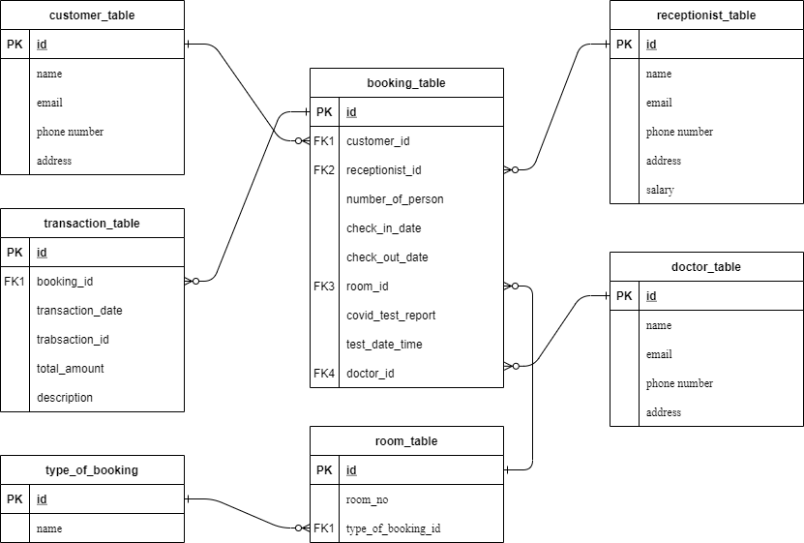

# **SQL COMMANDS**

## CREATE QUERIES:

CREATE DATABASE hotel_database;

USE hotel_database;

**-Table structure for table customer_table**

CREATE TABLE `customer_table` (

`id` int(11) NOT NULL AUTO_INCREMENT PRIMARY KEY,

`name` varchar(255) NOT NULL,

`email` varchar(255) NOT NULL,

`phone_number` varchar(255) NOT NULL,

`address` varchar(255) NOT NULL

) ENGINE=InnoDB DEFAULT CHARSET=latin1;

**-Table structure for table `doctor_table`**

CREATE TABLE `doctor_table` (

`id` int(11) NOT NULL AUTO_INCREMENT PRIMARY KEY,

`name` varchar(255) NOT NULL,

`email` varchar(255) NOT NULL,

`phone_number` varchar(255) NOT NULL,

`address` varchar(255) NOT NULL

) ENGINE=InnoDB DEFAULT CHARSET=latin1;

**-Table structure for table `receptionist_table`**

CREATE TABLE `receptionist_table` (

`id` int(11) NOT NULL AUTO_INCREMENT PRIMARY KEY,

`name` varchar(255) NOT NULL,

`email` varchar(255) NOT NULL,

`phone_number` varchar(255) NOT NULL,

`address` varchar(255) NOT NULL,

`salary` float NOT NULL

) ENGINE=InnoDB DEFAULT CHARSET=latin1;

**-Table structure for table `type_of_booking`**

CREATE TABLE `type_of_booking` (

`id` int(11) NOT NULL AUTO_INCREMENT PRIMARY key,

`name` varchar(255) NOT NULL

) ENGINE=InnoDB DEFAULT CHARSET=latin1;

**-Table structure for table `room_table`**

CREATE TABLE `room_table` (

`id` int(11) NOT NULL AUTO_INCREMENT PRIMARY KEY,

`room_no` int NOT NULL,

`type_of_booking_id` int NOT NULL,

CONSTRAINT `fk_type_of_booking_id` FOREIGN KEY (`type_of_booking_id`) REFERENCES `type_of_booking` (`id`)

) ENGINE=InnoDB DEFAULT CHARSET=latin1;

**-Table structure for table `booking_table`**

CREATE TABLE `booking_table` (

`id` int(11) NOT NULL AUTO_INCREMENT PRIMARY KEY,

`customer_id` int(11) NOT NULL,

`receptionist_id` int(11) NOT NULL,

`number_of_person` int(11) NOT NULL,

`checkin_date` datetime NOT NULL,

`checkout_date` datetime NOT NULL,

`room_id` int(11) NOT NULL,

`covid_test_report` varchar(255) NOT NULL,

`test_date_time` datetime NOT NULL,

`doctor_id` int(11) NOT NULL,

CONSTRAINT `fk_customer` FOREIGN KEY (`customer_id`) REFERENCES `customer_table` (`id`),

CONSTRAINT `fk_receptionist` FOREIGN KEY (`receptionist_id`) REFERENCES `receptionist_table` (`id`),

CONSTRAINT `fk_room` FOREIGN KEY (`room_id`) REFERENCES `room_table` (`id`),

CONSTRAINT `fk_doctor` FOREIGN KEY (`doctor_id`) REFERENCES `doctor_table` (`id`)

) ENGINE=InnoDB DEFAULT CHARSET=latin1;

**-Table structure for table `transaction_table`**

CREATE TABLE `transaction_table` (

`id` int(11) NOT NULL AUTO_INCREMENT PRIMARY KEY,

`booking_id` int(11) NOT NULL,

`transaction_date` datetime NOT NULL,

`total_amount` float NOT NULL,

`description` varchar(255) NOT NULL,

CONSTRAINT `fk_booking_id` FOREIGN KEY (`booking_id`) REFERENCES `booking_table` (`id`)

) ENGINE=InnoDB DEFAULT CHARSET=latin1;

## INSERT QUERIES

**-Inserting data in customer_table:**

INSERT INTO `customer_table` (`id`, `name`, `email`, `phone_number`, `address`) VALUES

(1, 'Wilson', 'Wilson@gmail.com', '0417596288', 'Mansfield, , Victoria, Victoria 3723'),

(2, 'Candy', 'Candy@gmail.com', '0419541439', 'Pakenham, Victoria, WARRAGUL, Victoria 3810'),

(3, 'Raspal', 'Raspal@gmail.com', '0458492045', 'BORONIA, Victoria, MELBOURNE, Victoria 3155'),

(4, 'Hansen', 'hansen@gmail.com', '0404189376', 'Berwick, VIC, BERWICK, Victoria 3806'),

(5, 'Chalmers', 'Chalmers@gmail.com', '0425137375', 'Ringwood, Vic, RINGWOOD NORTH, Victoria 3134'),

(6, 'Kirstin', 'Kirstin@gmail.com', '(03) 9084 7455', 'Ringwood, VIC, Ringwood, Victoria 3134'),

(7, 'Acciarito', 'Acciarito@gmail.com', '0405123068', 'Wantirna, VIC, Victoria 3152'),

(8, 'Janice Riley', 'JaniceRiley@gmail.com', '0413200499', 'Eltham, Victoria 3095'),

(9, 'Maxwell', 'Maxwell@gmail.com', '0456 033 200', 'DONCASTER EAST, Victoria 3095'),

(10, 'Kate', 'Kate@gmail.com', '03 9890 1062', 'Box Hill South, Victoria, BOX HILL SOUTH, Victoria 3128'),

(11, 'Melinda Millar', 'MelindaMillar@gmail.com', '03 9898 0222', 'Surrey Hills, Victoria, Victoria 3104');

**-Inserting data in doctor_table:**

INSERT INTO `doctor_table` (`id`, `name`, `email`, `phone_number`, `address`) VALUES

(1, 'Dr Jennifer', 'Jennifer@gmail.com', '1300 856 168', 'Carlton North, VIC, CARLTON NORTH, Victoria 3054'),

(2, 'Dr Viraj', 'DrViraj@gmail.com', '1300 874 325', 'Rouse Hill , NSW, BELLA VISTA, New South Wales 2155'),

(3, 'Dr J Arachchi', 'Arachchi@gmail.com', '0383 917 020', 'Hoppers Crossing, Victoira, Victoria 3029'),

(4, 'Dr Kemble ', 'KembleWang@gmail.com', '03 9928 6968', 'East Melbourne, Vic, Victoria 3002'),

(5, 'Dr Christine', 'Christine@gmail.com', '0492 867 653', 'Gympie , Qld, GYMPIE, Queensland 4570');

**-Inserting data in receptionist_table:**

INSERT INTO `receptionist_table` (`id`, `name`, `email`, `phone_number`, `address`, `salary`) VALUES

(1, 'Ms Naomi', 'Naomi@gmail.com', '(03) 9466-1160', 'Lalor, Victoria, LALOR, Victoria 3075', 10000),

(2, 'Edwards-Hart', 'EdwardsHart@gmail.com', '03 9005 5425', 'Kew, Victoria 3101', 11000),

(3, 'Brozovic', 'Brozovic@gmail.com', '0474 249 463', 'Kew, Victoria, Kew, Victoria', 11000),

(4, 'Melanie', 'Melanie@gmail.com', '0490166977', 'Hawthorn East, Victoria, HAWTHORN EAST, Victoria 3122', 11000);

**-Inserting data in type_of_booking:**

INSERT INTO `type_of_booking` (`id`, `name`) VALUES

(1, 'Single bed'),

(2, 'Double bed'),

(3, 'Rest Room'),

(4, 'Twin Bed Room'),

(5, 'President Suite'),

(6, 'Covid Room'),

(7, 'Executive Suite');

**-Inserting data in room_table:**

INSERT INTO `room_table` (`id`, `room_no`, `type_of_booking_id`) VALUES

(1, 101, 1),

(2, 102, 1),

(3, 103, 1),

(4, 104, 1),

(5, 201, 2),

(6, 202, 2),

(7, 203, 2),

(8, 204, 2),

(9, 301, 3),

(10, 302, 3),

(11, 401, 4),

(12, 402, 4),

(13, 501, 5),

(14, 502, 5),

(15, 503, 5),

(16, 504, 5),

(17, 601, 6),

(18, 602, 6),

(19, 603, 6),

(20, 604, 6),

(21, 605, 6),

(22, 606, 6),

(23, 701, 7),

(24, 702, 7),

(25, 703, 7),

(26, 704, 7);

**-Inserting data in booking_table:**

INSERT INTO `booking_table` (`id`, `customer_id`, `receptionist_id`, `number_of_person`, `checkin_date`, `checkout_date`, `room_id`, `covid_test_report`, `test_date_time`, `doctor_id`) VALUES

(1, 1, 1, 2, '2021-05-01 04:00:00', '2021-05-03 10:00:00', 5, 'Negative', '2021-05-04 00:00:00', 1),

(2, 2, 4, 1, '2021-05-06 08:00:00', '2021-05-20 10:00:00', 17, 'Positive', '2021-05-08 09:00:00', 3),

(3, 3, 3, 1, '2021-05-07 04:00:00', '2021-05-18 10:00:00', 18, 'Positive', '2021-05-08 00:00:00', 1),

(4, 4, 2, 1, '2021-05-17 06:26:07', '2021-05-31 10:00:00', 21, 'Positive', '2021-05-18 10:13:28', 4),

(5, 5, 1, 4, '2021-05-17 12:09:45', '2021-05-30 10:00:00', 14, 'Negative', '2021-05-17 00:00:00', 3),

(6, 6, 2, 1, '2021-05-13 11:13:17', '2021-05-15 10:00:00', 13, 'Negative', '2021-05-13 10:00:00', 2),

(7, 7, 3, 2, '2021-05-14 11:08:13', '2021-05-17 10:10:00', 12, 'Negative', '2021-05-13 07:31:20', 3),

(8, 8, 1, 4, '2021-05-03 08:19:33', '2021-05-21 10:00:00', 23, 'Negative', '2021-05-03 00:00:00', 5),

(9, 9, 4, 2, '2021-05-11 12:00:00', '2021-05-08 10:00:00', 13, 'Negative', '2021-05-05 00:00:00', 1),

(10, 10, 2, 8, '2021-05-03 08:22:00', '2021-05-22 10:00:00', 25, 'Negative', '2021-05-03 03:00:00', 3),

(11, 11, 1, 2, '2021-06-13 11:13:17', '2021-07-15 10:00:00', 11, 'Negative', '2021-06-13 10:00:00', 2);

**-Inserting data in transaction_table:**

## INSERT INTO `transaction_table` (`id`, `booking_id`, `transaction_date`, `total_amount`, `description`) VALUES

## (1, 1, '2021-05-01 00:00:00', 2566, 'Booking of room'),

## (2, 1, '2021-05-01 00:00:00', 500, 'Evening meal'),

## (3, 1, '2021-05-02 00:00:00', 524, 'Morning meal and cup of coffee'),

## (4, 1, '2021-05-03 00:00:00', 200, 'checkout fees'),

## (5, 2, '2021-05-06 00:00:00', 4324, 'lunch meal with tea'),

## (6, 2, '2021-05-07 00:00:00', 400, 'steam bath and cleaning of room'),

## (7, 3, '2021-05-07 00:00:00', 4104, 'lunch and cleaning of room'),

## (8, 3, '2021-05-08 00:00:00', 500, 'evening meal'),

## (9, 3, '2021-05-10 00:00:00', 854, 'morning meal'),

## (10, 3, '2021-05-11 00:00:00', 410, 'Dinner and juice'),

## (11, 4, '2021-05-17 00:00:00', 4512, 'booking of room and evening meal'),

## (12, 4, '2021-05-19 00:00:00', 854, 'Dinner and juice'),

## (13, 5, '2021-05-17 00:00:00', 4527, 'Booking of room and get dulex meal of lunch '),

## (14, 5, '2021-05-18 00:00:00', 451, 'breakfast and coffee cup'),

## (15, 6, '2021-05-13 00:00:00', 4785, 'booking and lunch meal'),

## (16, 6, '2021-05-14 00:00:00', 741, 'morning meal'),

## (17, 7, '2021-05-14 00:00:00', 7451, 'evening meal and booking of room'),

## (18, 7, '2021-05-16 00:00:00', 410, 'morning meal'),

## (19, 8, '2021-05-08 00:00:00', 4128, 'booking of room and night meal'),

## (20, 8, '2021-05-09 00:00:00', 400, 'morning meal'),

## (21, 9, '2021-05-03 00:00:00', 7451, 'evening meal and booking of room'),

## (22, 9, '2021-05-05 00:00:00', 410, 'morning meal'),

## (23, 10, '2021-05-03 00:00:00', 4128, 'booking of room and night meal'),

## (24, 11, '2021-05-13 00:00:00', 400, 'morning meal');

## SELECT QUERIES

**1. Simple Select queries.**

**A. Show all customer:** (This query will show all the customers in hotel)

SELECT * FROM customer_table ORDER BY name ASC;

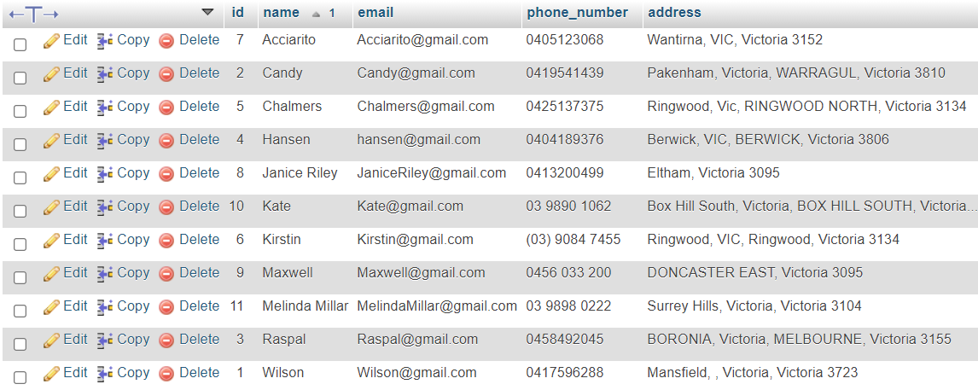

**B. Show all doctors:** (This query will show all the doctors’ work in the hotel)

SELECT * FROM doctor_table ORDER BY name ASC;

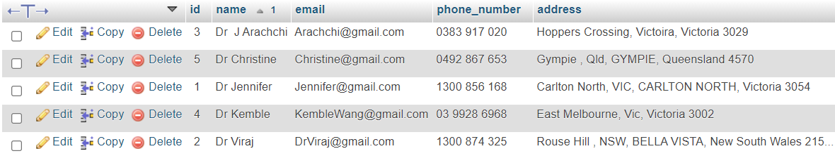

**C. Show all Receptionists:** (This query will show all the details of receptionists in the hospital)

SELECT * FROM receptionist_table ORDER BY name ASC;

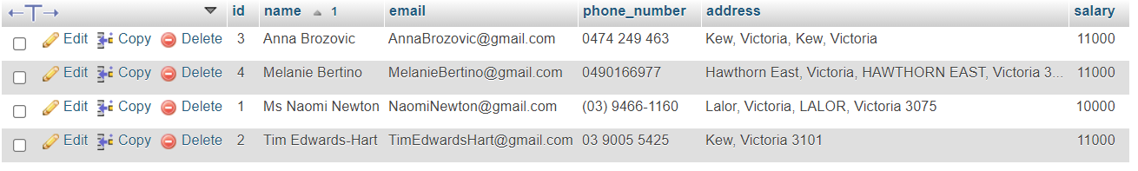

**D. Show all type of rooms:** (This query will show the types of rooms available in hotel)

SELECT * FROM type_of_booking ORDER BY name ASC;

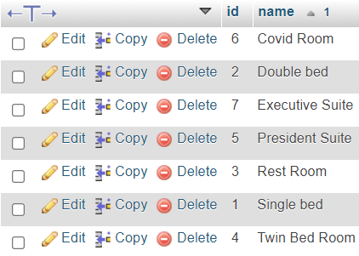

**E. Show total number of room:** (This query will show number of rooms available in hotel)

SELECT COUNT(*) as total_number_of_room FROM room_table

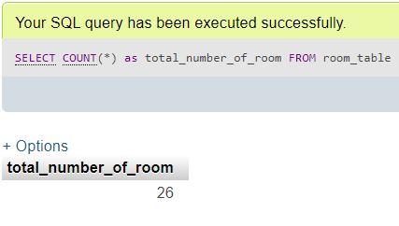

**F. Show total number of customers:** (This query will show number of customers staying in hotel)

SELECT COUNT(*) as total_number_of_customer FROM customer_table

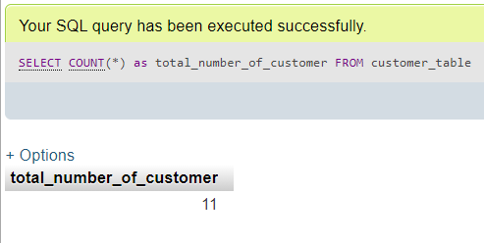

**G. Show total number of doctor:** (This will show total number of doctors in the hotel)

SELECT COUNT(*) as total_number_of_doctoer FROM doctor_table

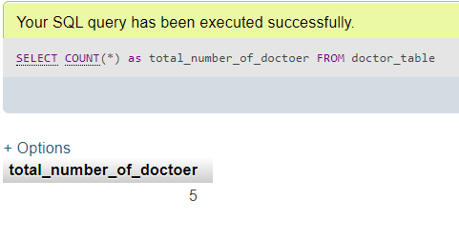

**H. Show total number of receptionists:** (Showing number of receptionists working in hotel)

SELECT COUNT(*) as total_number_of_receptionist FROM receptionist_table

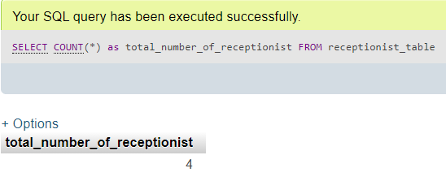

**2. Select query with where conditions**

**A. Show information of doctor name is Dr Jennifer:** (This query will filter out the details of doctor with doctor name)

SELECT * FROM doctor_table WHERE name='Dr Jennifer'

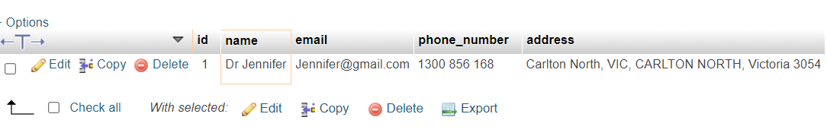

**B. Show information about receptionist where salary > 9000:** (It will list out all the receptionists with salary more than 9000)

SELECT * FROM receptionist_table WHERE salary >= 9000 ORDER BY name ASC

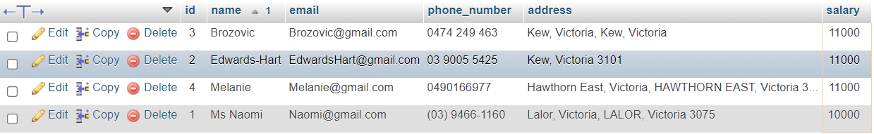

**C. Show room type where value Double bed and Executive Suite:** (Filter out double bed and executive rooms)

SELECT * FROM type_of_booking WHERE name IN ('Double bed','Executive Suite') ORDER BY name ASC;

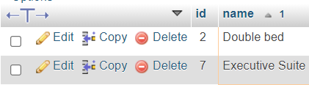

**D. Show those booking which are COVID positive:** (Filter out customers with COVID positive reports)

SELECT * FROM booking_table WHERE covid_test_report='Positive'



**E. Show only those booking which start from 2021-05-01 and end 2021-05-10:** (Filter out bookings in particular Date range)

SELECT * FROM booking_table WHERE checkin_date BETWEEN date('2021-05-01') and date('2021-05-10')

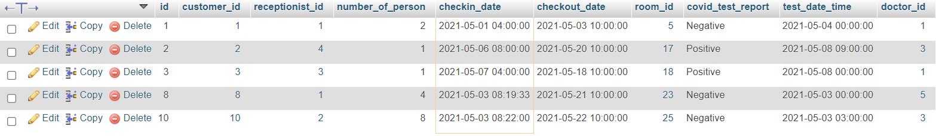

**3. Select Queries with joins**

**A. Show room and what kind are they:** (Showing all the rroms and their type of bookings)

SELECT t.name,r.* FROM room_table as r INNER JOIN type_of_booking as t ON t.id=r.type_of_booking_id ORDER BY t.name ASC;

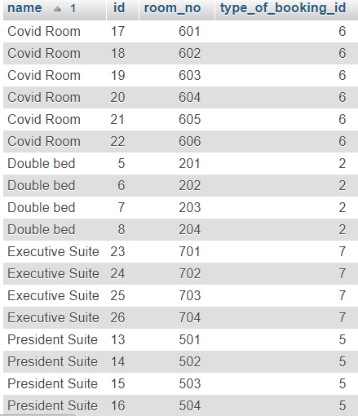

**B. Show complete booking table:** (Displaying each and every details of booking)

SELECT c.name as customer_name,r.name as receptionist_name,d.name as doctor_name,t.name,b.* FROM booking_table as b INNER JOIN customer_table as c ON c.id=b.customer_id INNER JOIN receptionist_table as r ON r.id=b.receptionist_id INNER JOIN room_table as ro ON ro.id=b.room_id INNER JOIN doctor_table as d ON d.id=b.doctor_id INNER JOIN type_of_booking as t ON t.id=ro.type_of_booking_id

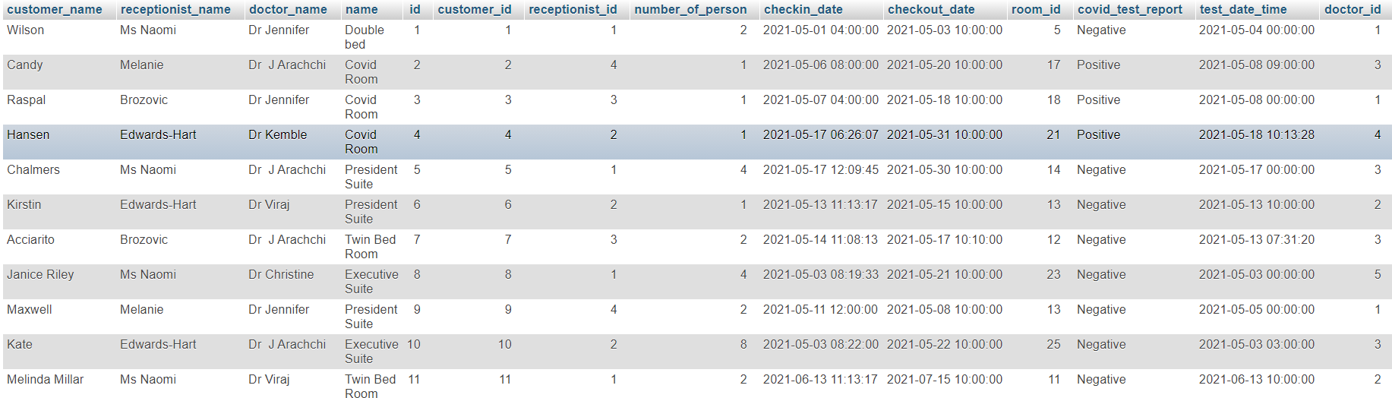

**C. Complete transaction details according to customer:** (Details about all transactions)

SELECT tr.*,c.name as customer_name FROM booking_table as b INNER JOIN customer_table as c ON c.id=b.customer_id INNER JOIN transaction_table as tr ON tr.booking_id=b.id

